Thermo Shaker (with heating lid)—TPS2000
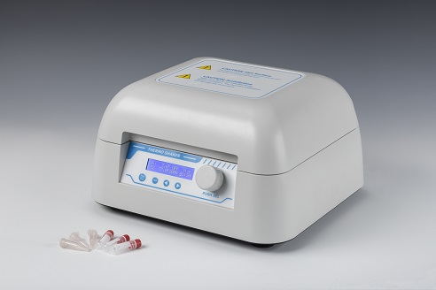
Description:
TPS2000 Thermo Shaker (with heating lid) is a multipurpose thermostatic shaker controlled by brushless DC motor. Its PID intelligent temperature control technology ensures the temperature accuracy, automatically adjusts the heating rate and reduces waiting time. Heating lid temperature control function can effectively prevent the phenomenon of evaporation and tube burst, and greatly improve the temperature uniformity in the test tube. It is the ideal automation tool for sample incubation, catalysis, blending and preservation.

Features:
- LCD display. It is easy to setup and use.
- Accurate temperature control, high stability.
- Dual-blocks with large capacity.
- Max. speed to 2000rpm.
- Two options for heating lid temperature control: automatic or manual.
- Brushless DC motor: noiseless long service life maintenance-free.
- Support multi points running function.
- Automatic preheating function.
- Auto resume to run after power failure.
- Automatic running function.
- Built-in temperature calibration function.
- Built-in over-heating protection device, safe and reliable.

Parameters:
Project | Parameters
Temp. setting range | 0°C~100°C
Temp. control range | RT.+5°C~100°C
Time range | 1min~99h59min/∞
Temp. accuracy | ≤±0.2°C@37°C
Display accuracy | 0.1°C
Temp. uniformity | ≤±0.2°C@37°C
Heating lid temp. setting range | Auto/0~+15°C
Heating lid temp. control mode | Automatic / Manual
Speed range | 200~2000rpm
Orbit | 2mm
Heating time | ≤15min(from 25°C to 100°C)
Multi point running | Yes(Max 5points)
Multi cycle | Yes(Max 99times)
Auto constant temp. at the end of run | Yes
Auto preheating | Yes
Auto running | Yes
Auto resume to run | Yes
Block quantity | 2
Power supply | 450W
Voltage | AC220V/50-60Hz
Fuse | 250V 3A Ф5×20
Dimension(mm) | 340x320x200
Weight(kg) | 10.7
Optional blocks
Type | Capacity | Max Speed
MD30 | 96x0.2ml PCR Plate | 2000rpm
MD31 | 54x0.5ml centrifuge tube | 2000rpm
MD32 | 35x1.5ml centrifuge tube | 2000rpm
MD33 | 35x2.0ml centrifuge tube | 2000rpm
MD34 | 20x1.5ml+15x0.5ml centrifuge tube | 2000rpm

